Dear CEBC & ECIC member,
Kindly find below the special benefits from Solana Dental Esthetics for our valued members;
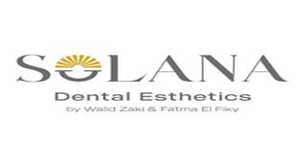
We are glad to offer CEBC & ECIC members,10% discount off will be applied For
1.implaments
2.crowns and veneers
3.Orthodonic Treatment
4.Simple Extractions
*15% discount will be applied For
1.Scaling and Polishing
2.Whitening
3.Filling
4.Simple Extractions
BECAUSE EVERY SMILE MATTERS RESERVE YOUR APPOIMTMENT AT
CONTACT NUMBER: 01553677999

Reservation Link :https//www.instagram.com/solanadentalesthetics

This offer is valid till 31 December 2025.

**N. B: Each member at CEBC should present his 2025 membership ID in order to guarantee the benefits

