Dear CEBC & ECIC member,

Kindly find below the special benefits from Ora Developments for our valued members;

We are glad to offer CEBC & ECIC members,**2% discount off** will be applied on the best available rates at **Ora Developments**:

1. North Coast, Egypt

**1% discount** will be applied on the rest of the Projects

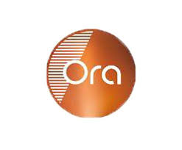

**Contact Number:** 01050055059

**Email:**Mohabdallah212@gmail.com

**This offer is valid till 31 December 2025.**

* **\*\*N. B: Each member at CEBC should present his 2025 membership ID in order to guarantee the benefits**

**CEBC & ECIC**

**Tel.: 02 22913675 - 02 22914975**

**Mob.: 0100 122 1364 – 0100 077 6584**

**WhatsApp : 0100 122 1364**

**Address: Square One Business Complex, 3rd floor, Plot No.2,**

**Touristic Zone – El Choueifat, 5th Settlement, New Cairo, 11835-Egypt**

**Email:** [**membership@canadaegypt.org**](mailto:member@canadaegypt.org)

**Web:** [**www.canadaegypt.org**](http://www.canadaegypt.org)

Description: Description: Description: Description: Description: Image result for facebook icon

