Dear CEBC & ECIC member,

Kindly find below **the special benefits** from **“Some Korean skincare”** for our valued members; This offer is **valid till 31 December 2025.**

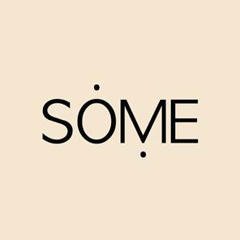

**\*\*N. B: Each member at CEBC should present his 2025 membership ID in order to guarantee the benefits**