Dear CEBC & ECIC member,

We are delighted to offer you special “Winter Promotion for Renovated Rooms” from **Sheraton Soma Bay Resort** for our valued members;

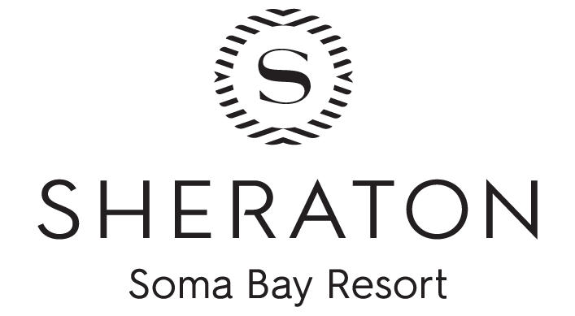

**Half Board Rates**

|  |  |  |  |
| --- | --- | --- | --- |
| **From** | **To** | **Single room rate** | **Double room rate** |
| 14-Jan-2025 | 25-Mar-2025 | EGP 6500 | EGP  7300 |

* The above mentioned rates are inclusive of service charge and all applicable taxes.
* The above mentioned rates are based on Half Board (Breakfast & Dinner)

The above winter rates are valid until **March 25th, 2025.**

 Reservation:

* All bookings will be subject to hotel availability at the time of the booking.
* Hotel Reservation Department:
* Telephone                              : +20 65 356 2500
* Fax                                         : +20 65 356 2580
* E-mail                                    :   [Reservations.01127@marriott.com](mailto:Reservations.01127@marriott.com)

***\*\*N.B: Each member at CEBC & ECIC should present his 2025 membership ID in order to guarantee the benefits at the hotel.***