Dear CEBC & ECIC member,
Kindly find below the special benefits from Gold’s Gym for our valued members;
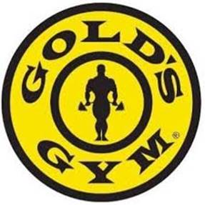

Membership Benefits:
• Four (4) complimentary training sessions with a certified trainer, plus one
(1) free nutrition consultation.
• Gold's Gym VIP Passport: Fourteen (14) visits valid at each branch in Egypt
(25 branches).
• Free International Passport: Fourteen (14) visits at more than 1,000 branches worldwide.
Option to freeze the membership for two (2) months.
• Daily aerobic classes: Step, dance, martial arts, and a variety of group fitness sessions.
Branch Facilities:
Operating hours: 6:00 AM - 12:00 midnight.
Private women's workout area, latest aerobic and fitness equipment, including spinning studios.
Private Men's Spa: lockers, sauna, and steam room.
Private Women's Spa: lockers, sauna, Jacuzzi, and steam room.
Dedicated CrossFit area and specialized classes.

Branches
Golden Heights 36 K
Offer 16 K

Elshorouk 32 K
Offer14,500 K

Sheraton 18 K
Offer10 K

Heliopolis 18 K
Offer10 K
This offer is valid till 5 November 2025.
- **N. B: Each member at CEBC should present his 2025 membership ID in order to guarantee the benefits

