The world is experiencing many crises and rapid changes as a result of geopolitical tensions, slow growth rates, and the risks of climate change, which impose major challenges on various economies around the world, especially in light of rising global inflation and energy challenges. The Egyptian government has adopted a package of strategies and plans over the past years to reduce the effects of these repercussions on the economy, but despite these efforts, the Egyptian economy still faces some challenges that require searching for new and innovative solutions, so that it can withstand these crises.

In this context, Canada Egypt Business Council and the Egyptian Business Council for International Cooperation will hold its next forum

With:

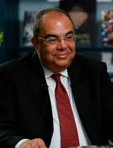

**Dr. Mahmoud Mohieldin**

**UN Special Envoy for Financing Sustainable Development**

**Under the topic:**

**“Managing the Economy in a Changing World "**

### The event will be held on Tuesday, November 19th, at Nile Ritz-Carlton Hotel, Alf Leila w Leila Ballroom

**Agenda:**

**5:00-6:00 p.m. Registration & Networking**

**6:00-8:00 p.m. Discussion and Q&A**

**--------------------------------**

**--------------------------------**

**To confirm your attendance, kindly fill in the below form**

<https://forms.gle/vhjTWbU6CtBa2pJL8>

**Confirmation should be sent maximum by Sunday 17th of November**

**Payment at CEBC premises or through our bank account:**

**Arab African International Bank, Heliopolis Branch.**

**Account No # 101311 - 84100 – 20201 / available through InstaPay**

**Swift Code: ARAIEGCXHEL**

**CEBC members are Free of charge**

**Fees for CEBC Guests EGP 700**

**Payment at the door L.E. 750**

**Fees for table reservation:**

•**EGP 8,000** for regular tables & **EGP 10,000** for premium tables location

\*\***Limited VIP tables available upon request**

**For table reservations & sponsorship packages, please contact**

**Ms. Eman Selim:** **Executive Director, Mob. 01001664449, E-mail:** [**Eman.selim@canadaegypt.org**](mailto:Eman.selim@canadaegypt.org)

**Ms. Marianne Samir:** **Operations Manager, Mob. 01023289205, E-mail:** [**marianne.samir@canadaegypt.org**](mailto:marianne.samir@canadaegypt.org)

**To join or invite guests to join our online live event, kindly click on the below link to log in to our YouTube channel on**

**Tuesday, November 19th, at 6:00 pm**

<https://www.youtube.com/channel/UC-_NY48jGsDqgdBbEQsipPg>

***Please do not hesitate to add your comments or questions throughout the event for live discussion with Dr. Mahmoud Mohieldin***

**CEBC Corporate Partners**

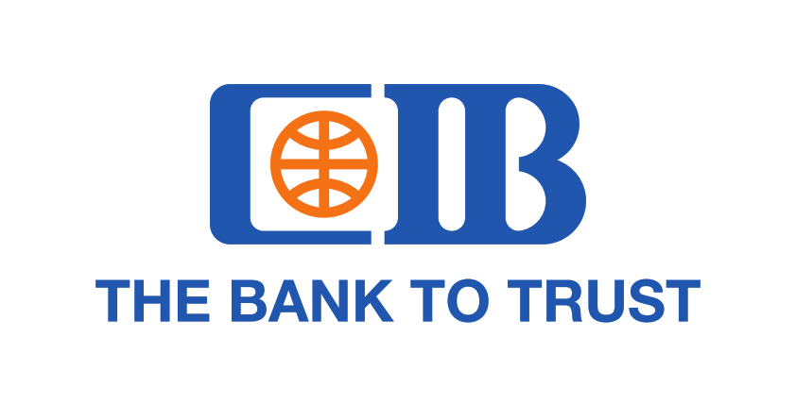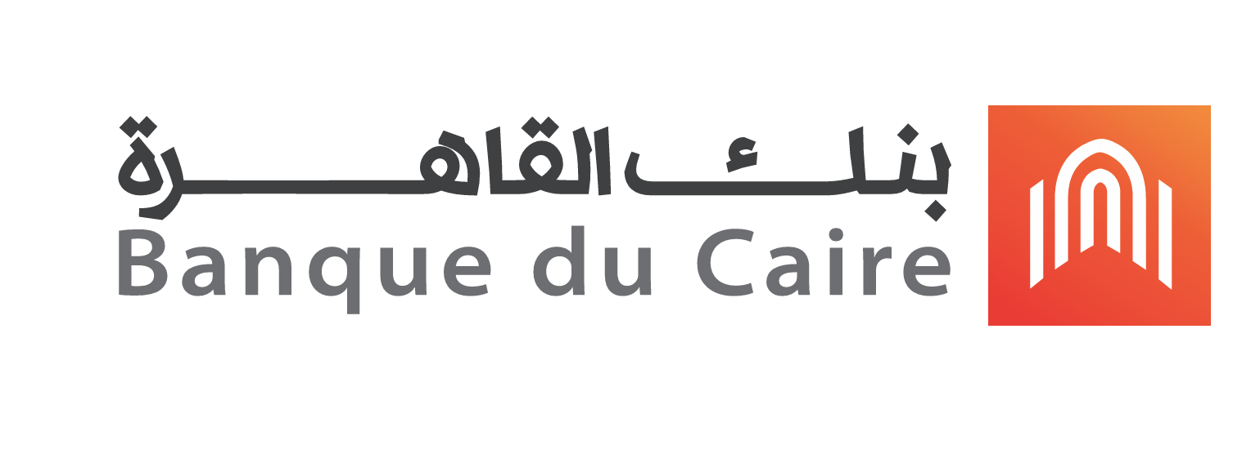

**CEBC Corporate Sponsors**

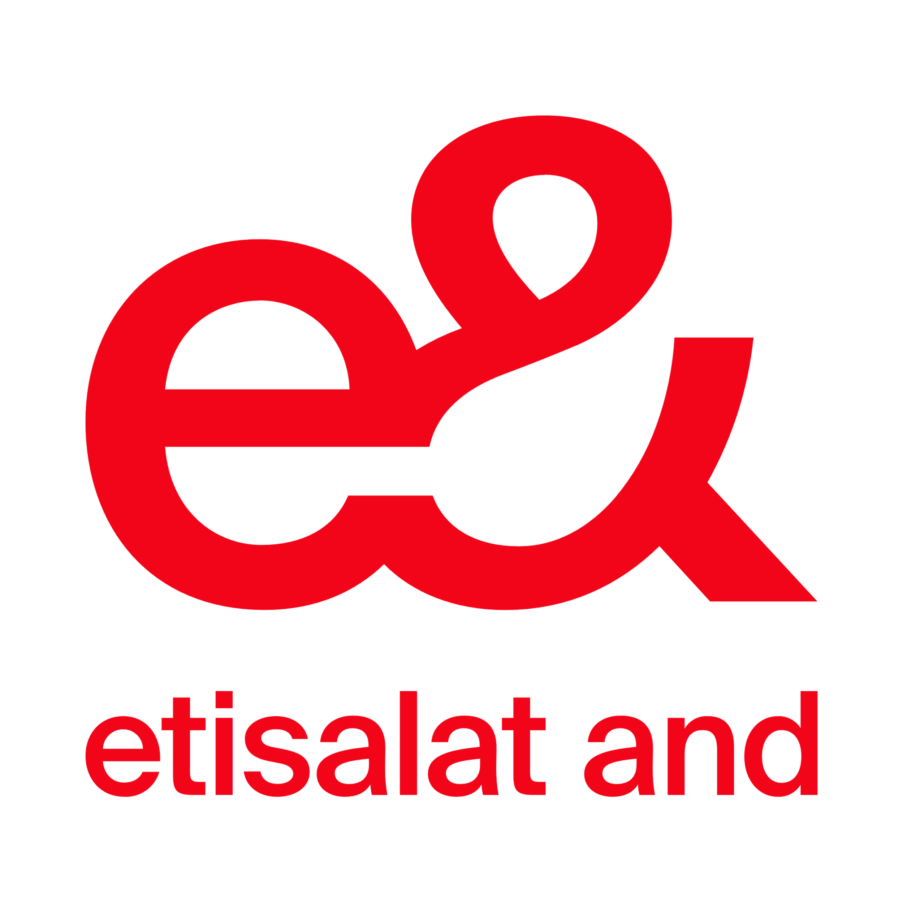 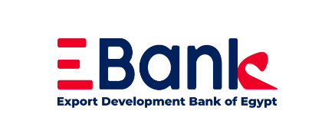[](https://www.qnb.com.eg/sites/qnb/qnbegypt/page/en/en-home.html) 