Dear CEBC & ECIC member,
Kindly find below the special benefits from 3 DINER for our valued members;
We are glad to offer CEBC & ECIC members,15% discount off will be applied for 3DINER across ALL THEIR BRANCHES.

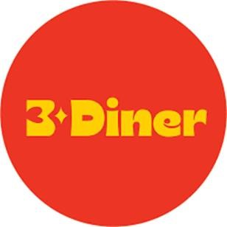

This offer is valid till 31 December 2025

**N. B: Each member at CEBC should present his 2025 membership ID in order to guarantee the benefits

